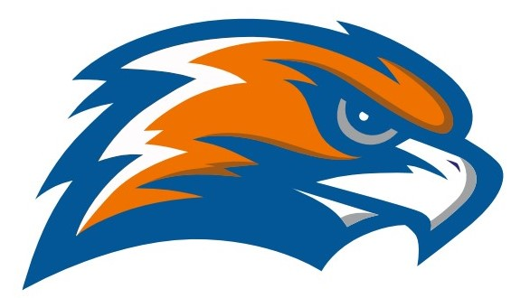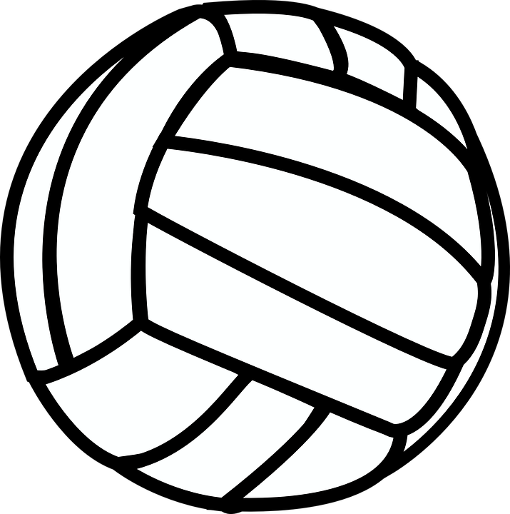

| **GARRETT MORGAN VOLLEYBALL 2021** |
| --- |

Head Coach Tracy Evensen Assistant Coach Sydney Taylor

Athletic Director Jennifer Smith

Principal GMSEI Quenton Davis

Principal GMSLI Anshawn Ivery – Administrator for Athletics

| **DATE** | **TIME** | **VISITOR** | **HOME** | **SITE** |
| --- | --- | --- | --- | --- |
| **Monday**  **8/23** | **4:00** | **Bard** | **Garrett Morgan** | [**Garrett Morgan**](https://www.google.com/maps/place/4600+Detroit+Ave,+Cleveland,+OH+44102/@41.4873642,-81.7224151,17z/data=!3m1!4b1!4m5!3m4!1s0x8830f0469e54d3f3:0xdce7d05d4701a202!8m2!3d41.4873602!4d-81.7202211) |
| **Wednesday**  **8/25** | **4:00** | **Garrett Morgan** | **Lincoln West** | [**Lincoln West**](http://maps.google.com/maps?q=3202+W.+30th+St.+Cleveland+OH+44109&hl=en&sll=41.563653,-81.566807&sspn=0.007128,0.050211&hnear=3202+W+30th+St,+Cleveland,+Ohio+44109&t=m&z=14) |
| **Friday**  **8/27** | **4:00** | **John F. Kennedy** | **Garrett Morgan** | [**Garrett Morgan**](https://www.google.com/maps/place/4600+Detroit+Ave,+Cleveland,+OH+44102/@41.4873642,-81.7224151,17z/data=!3m1!4b1!4m5!3m4!1s0x8830f0469e54d3f3:0xdce7d05d4701a202!8m2!3d41.4873602!4d-81.7202211) |
| **Friday**  **9/3** | **4:00** | **Glenville** | **Garrett Morgan** | [**Garrett Morgan**](https://www.google.com/maps/place/4600+Detroit+Ave,+Cleveland,+OH+44102/@41.4873642,-81.7224151,17z/data=!3m1!4b1!4m5!3m4!1s0x8830f0469e54d3f3:0xdce7d05d4701a202!8m2!3d41.4873602!4d-81.7202211) |
| **Wednesday**  **9/8** | **4:00** | **Garrett Morgan** | **Collinwood** | [**Collinwood**](http://maps.google.com/maps?q=15210+St.+Clair+Avenue+Cleveland+OH+44110&hl=en&sll=41.520615,-81.613389&sspn=0.006876,0.050211&hnear=15210+St+Clair+Ave,+Cleveland,+Ohio+44110&t=m&z=14) |
| **Friday**  **9/10** | **4:00** | **Campus International** | **Garrett Morgan** | [**Garrett Morgan**](https://www.google.com/maps/place/4600+Detroit+Ave,+Cleveland,+OH+44102/@41.4873642,-81.7224151,17z/data=!3m1!4b1!4m5!3m4!1s0x8830f0469e54d3f3:0xdce7d05d4701a202!8m2!3d41.4873602!4d-81.7202211) |
| **Monday**  **9/13** | **4:00** | **Garrett Morgan** | **John Adams** | [**John Adams**](https://www.google.com/maps/place/3817+Martin+Luther+King+Jr+Dr,+Cleveland,+OH+44105/@41.4546368,-81.6039104,17z/data=!3m1!4b1!4m2!3m1!1s0x8830fcaac6345945:0x1b22a1796a402ee0?hl=en) |
| **Wednesday**  **9/15** | **4:00** | **Max Hayes** | **Garrett Morgan** | [**Garrett Morgan**](https://www.google.com/maps/place/4600+Detroit+Ave,+Cleveland,+OH+44102/@41.4873642,-81.7224151,17z/data=!3m1!4b1!4m5!3m4!1s0x8830f0469e54d3f3:0xdce7d05d4701a202!8m2!3d41.4873602!4d-81.7202211) |
| **Monday**  **9/20** | **4:00** | **John Marshall** | **Garrett Morgan** | [**Garrett Morgan**](https://www.google.com/maps/place/4600+Detroit+Ave,+Cleveland,+OH+44102/@41.4873642,-81.7224151,17z/data=!3m1!4b1!4m5!3m4!1s0x8830f0469e54d3f3:0xdce7d05d4701a202!8m2!3d41.4873602!4d-81.7202211) |
| **Friday**  **9/24** | **4:00** | **John Hay** | **Garrett Morgan** | [**Garrett Morgan**](https://www.google.com/maps/place/4600+Detroit+Ave,+Cleveland,+OH+44102/@41.4873642,-81.7224151,17z/data=!3m1!4b1!4m5!3m4!1s0x8830f0469e54d3f3:0xdce7d05d4701a202!8m2!3d41.4873602!4d-81.7202211) |
| **Monday**  **9/27** | **4:00** | **Garrett Morgan** | **James F. Rhodes** | [**James F. Rhodes**](http://maps.google.com/maps?q=5100+Biddulph+Ave+Cleveland+OH+44144&hl=en&sll=41.563702,-81.592884&sspn=0.007128,0.050211&hnear=5100+Biddulph+Ave,+Cleveland,+Ohio+44144&t=m&z=14) |
| **Wednesday**  **9/29** | **4:00** | **East Tech** | **Garrett Morgan** | [**Garrett Morgan**](https://www.google.com/maps/place/4600+Detroit+Ave,+Cleveland,+OH+44102/@41.4873642,-81.7224151,17z/data=!3m1!4b1!4m5!3m4!1s0x8830f0469e54d3f3:0xdce7d05d4701a202!8m2!3d41.4873602!4d-81.7202211) |

**SENATE PLAYOFFS - Monday October 4**

1st SEED VS 4th SEED @ TBA 4:00 pm

2nd SEED VS 3rd SEED @ TBA 4:00 pm

**SENATE CHAMPIONSHIP - Wednesday October 8**

East Professional Center

**OHSAA SECTIONALS - October 18 - 23 TBA**

**Senate Athletic League**

**Bard Campus International East Tech Collinwood Garrett Morgan Glenville**

**James F. Rhodes John Adams John Hay John F. Kennedy John Marshall Lincoln West**

**Max Hayes**